Cross-Region Replication (CRR) in Amazon S3 allows you to automatically copy objects from one S3 bucket (source) to another bucket (destination) in a different AWS region. This is useful for disaster recovery, compliance, and performance optimization.

**Create a New Bucket:**

* Click on **"Create bucket"**.
* Enter a **unique bucket name** (e.g., my-source-bucket).
* Choose a **region** (e.g., us-east-1).

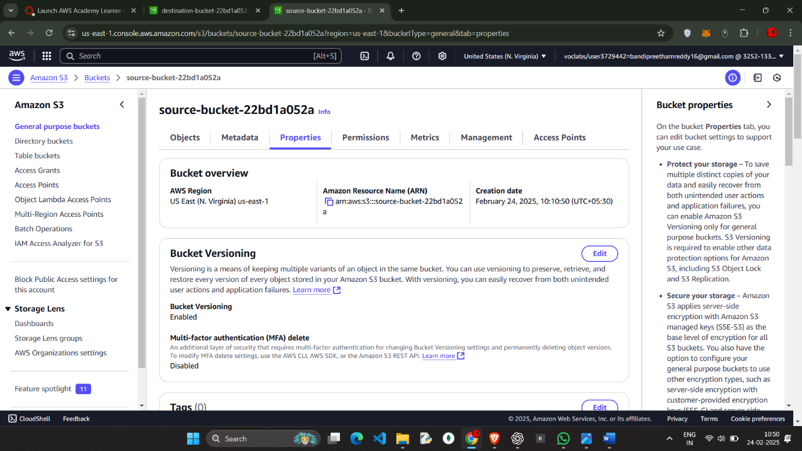

Create the destination Bucket with name destination-22bd1a052a

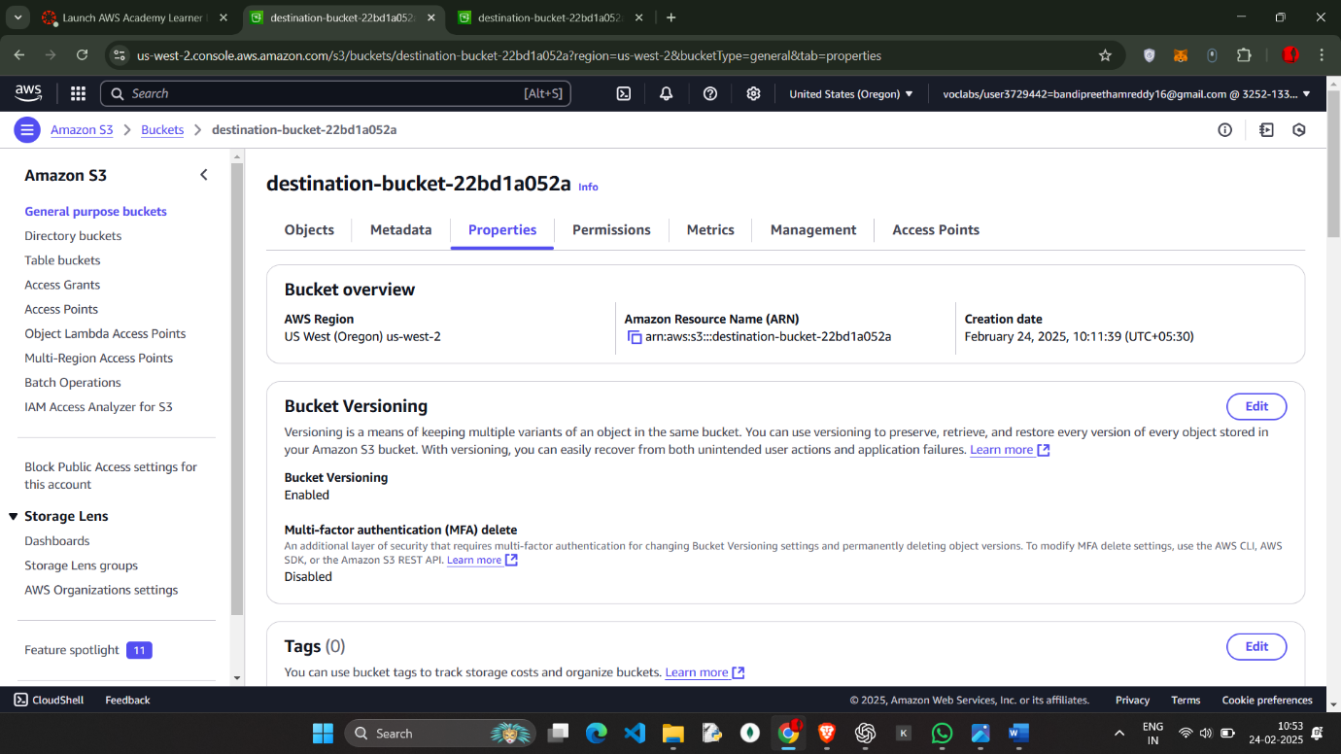  
Enable the vesoning in both the buckets

And go to the Source-bucket and go to MANAGEMENT

And Click on **Create replication rule**.

Enter the name as CRR1

And Destination (Choose the bucket in this account)

Choose the IAM role 🡪 choose from the existing IAM roles

And SAVE the changes

And upload the a.txt file in the source

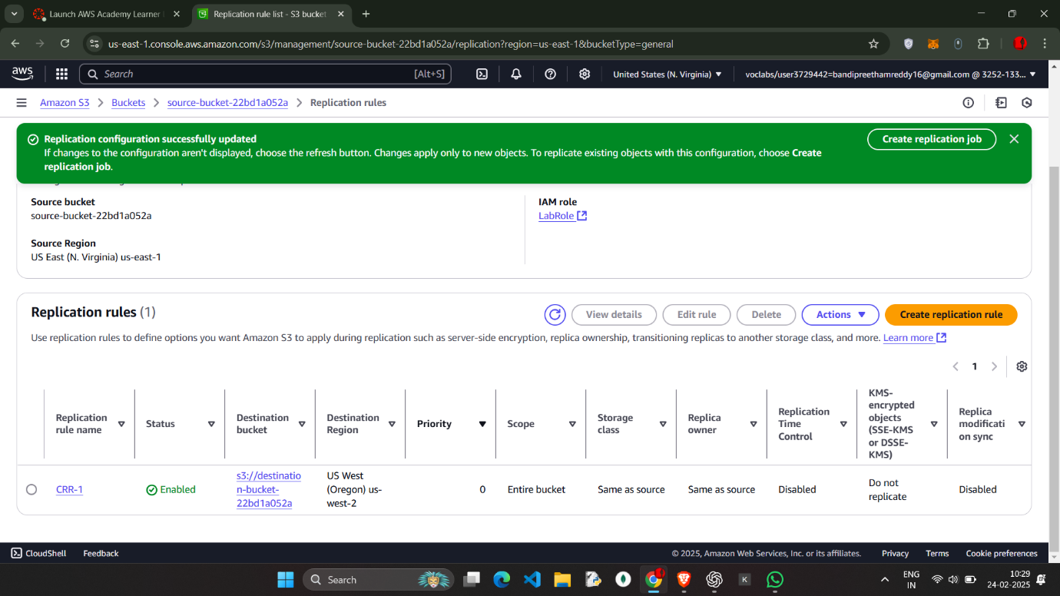

Upload the a.txt

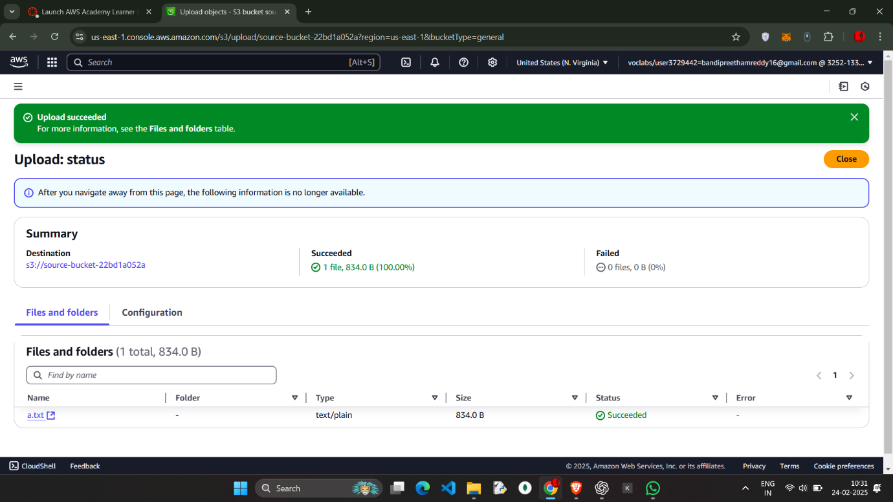

Upload the a.txt

* Click on the destination-bucket we will have a.txt object existing which came from the source-bucket (Cross – region – replication)
* 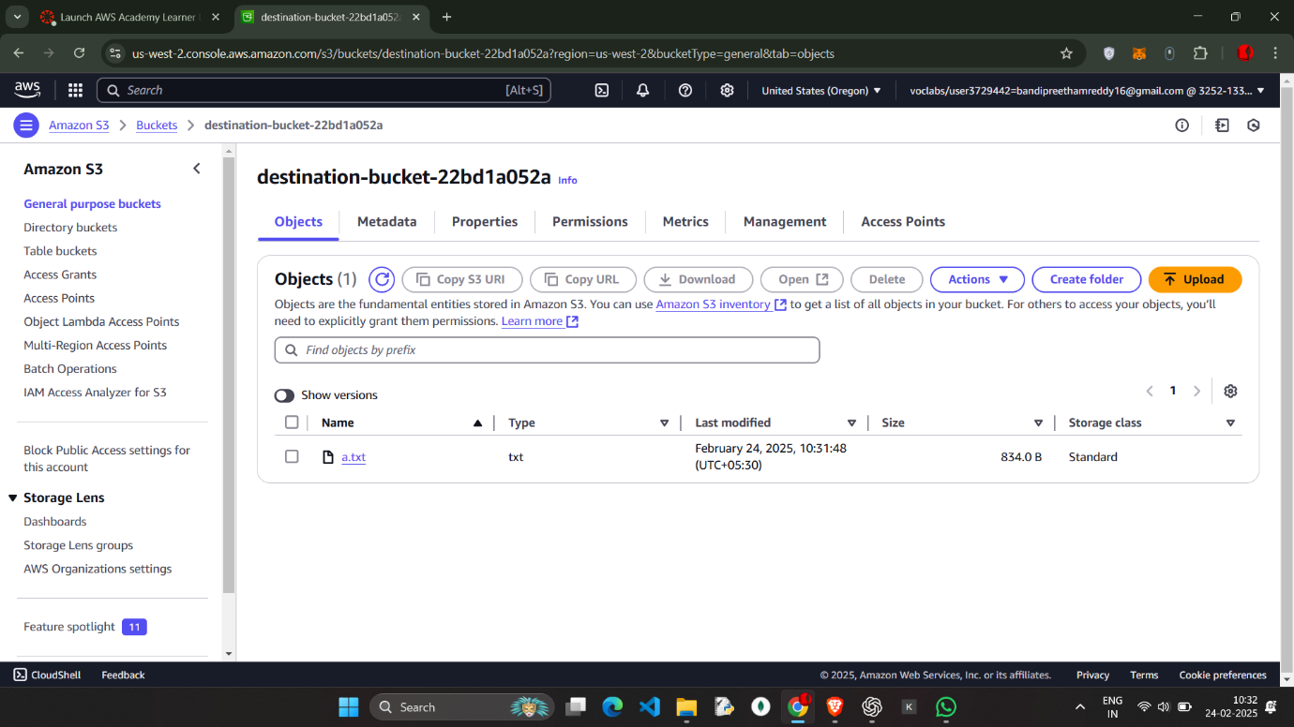

Now similarly Do the process where the Destination—bucket as the source and source as the destination and continue the process

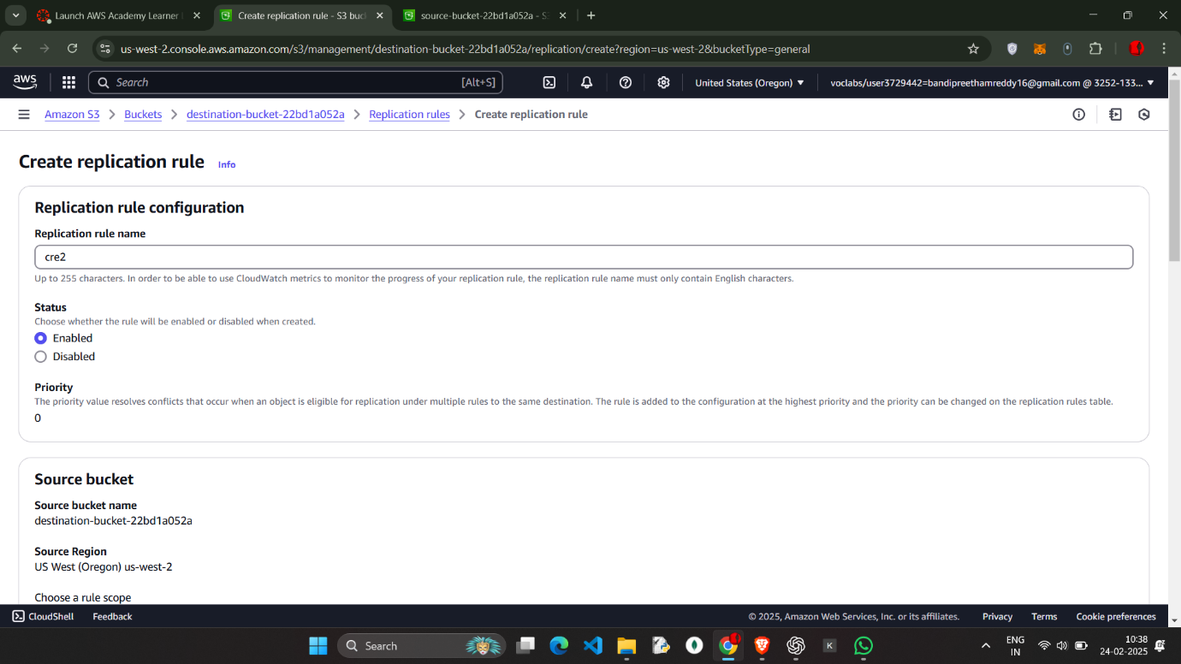

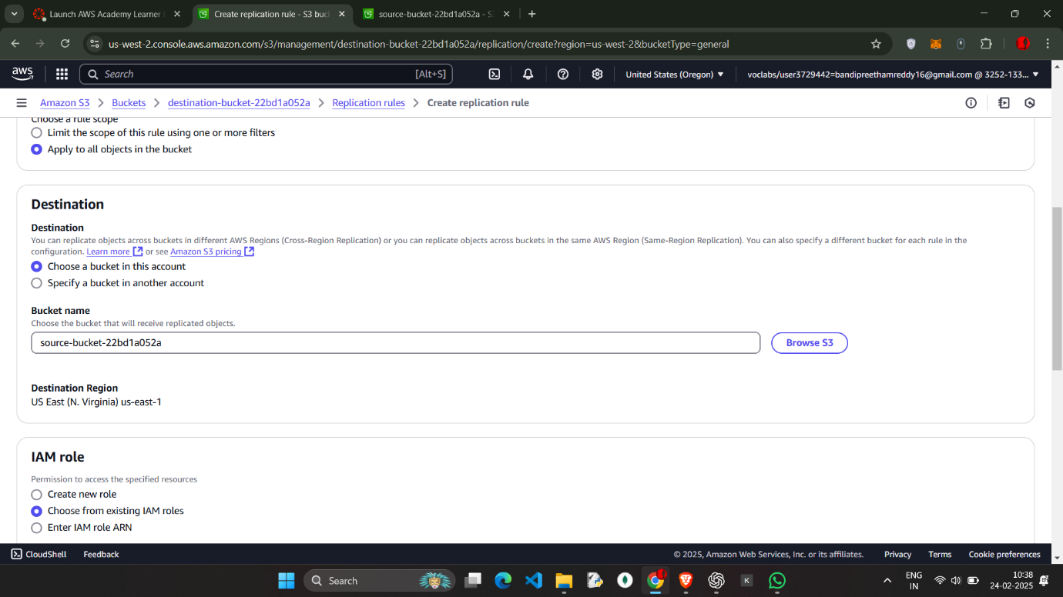

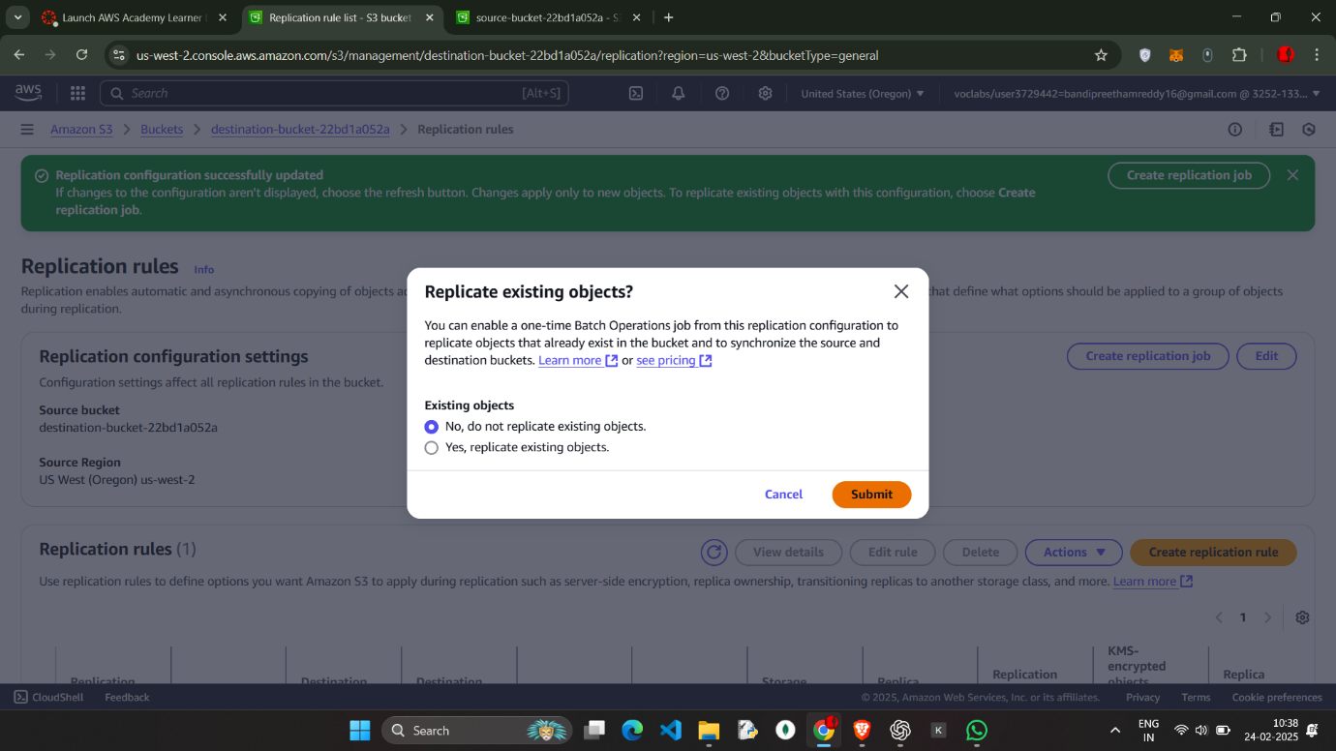

Upload the Feedback.html in the destination which will reflected in the Source bucket

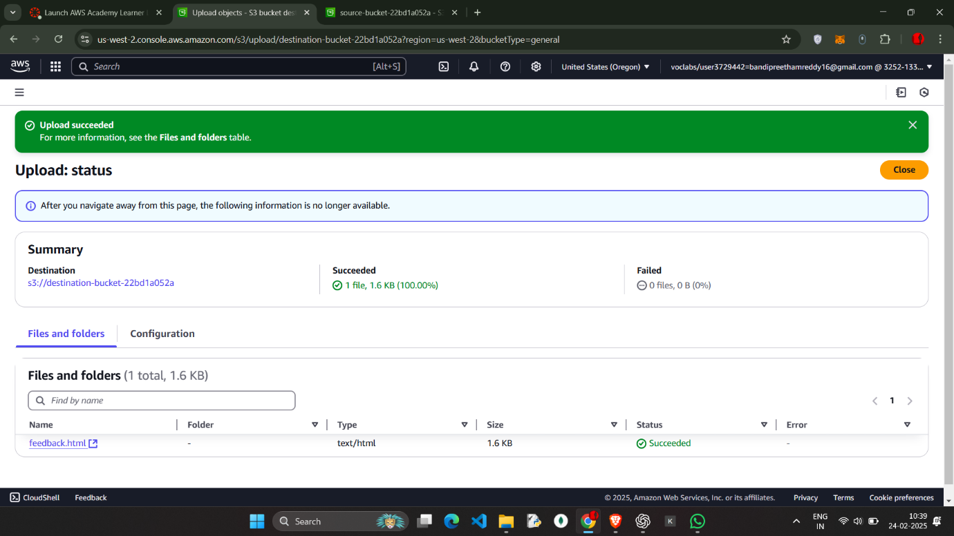

-🡪 click on the source bucket and check for the feedback.html (object)

